Supplementary Material for:

A streamlined protocol for emulsion PCR and subsequent purification

Tatjana Schütze^{1,2}, Florian Rubelt^{1,2}, Julia Repkow¹, Nicole Greiner¹, Volker A Erdmann², Hans Lehrach¹, Zoltán Konthur¹, Jörn Glökler¹

¹ Department of Vertebrate Genomics, Max Planck Institute for Molecular Genetics, Ihnestrasse 63-73, 14195 Berlin, Germany
² Institute for Chemistry / Biochemistry, Freie Universität Berlin, Thielallee 63, 14195 Berlin, Germany

Optimization of organic solvent usage for breaking emulsions

From several different organic solvents including ethanol, isopropanol, pyrrolidone and acetone, only butanol and isobutanol were able to break the emulsion efficiently. The yield of PCR-product in the purification process was strongly increased by addition of binding buffer from the DNA cleanup kit (GeneMatrix PCR/DNA kit, EURx, Poland) broken emulsion. This was shown by a mock PCR reaction containing DNA molecules of different length (GeneRulerTM 100bp, Fermentas, Germany) that was first emulsified and subsequently broken and purified (suppl. figure S1.).
Butanol and isobutanol were equally efficient, however further experiments were carried out with isobutanol because of the less problematic side products formed by oxidation.
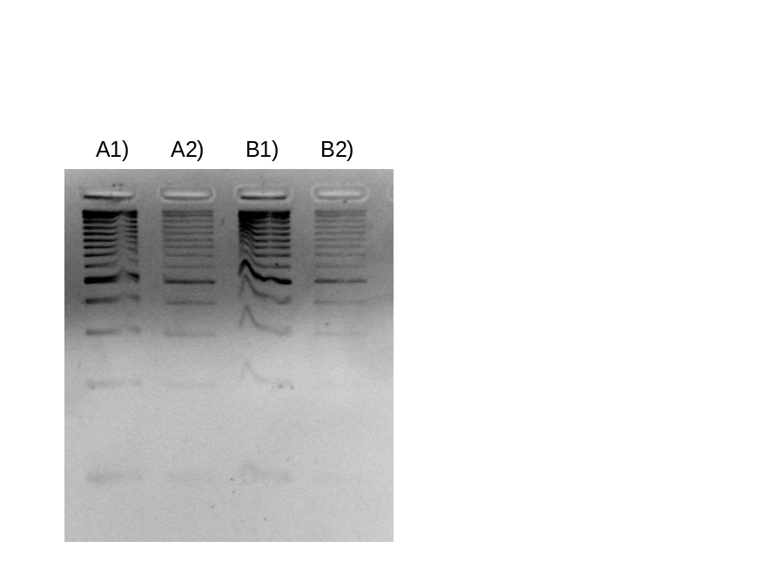
Supplementary Figure S1: Comparison of GeneRulerTM 100bp (Fermentas) purified from an emulsified mock PCR-mix treated with A) isobutanol and B) butanol, supplemented 1) with binding buffer and 2) without, visualized by Ethidium bromide stained 3% agarose gel

Microscopy of emulsion after vortexing

After addition of the aqueous phase to the oil-surfactant mixture the emulsion was generated by vortexing at +10°C. An aliquot was taken at 1 min intervals and the quality of the emulsion visualized by Laser Scanner LSM 510 (see Figure S2). It is advised to vortex for 5 min.

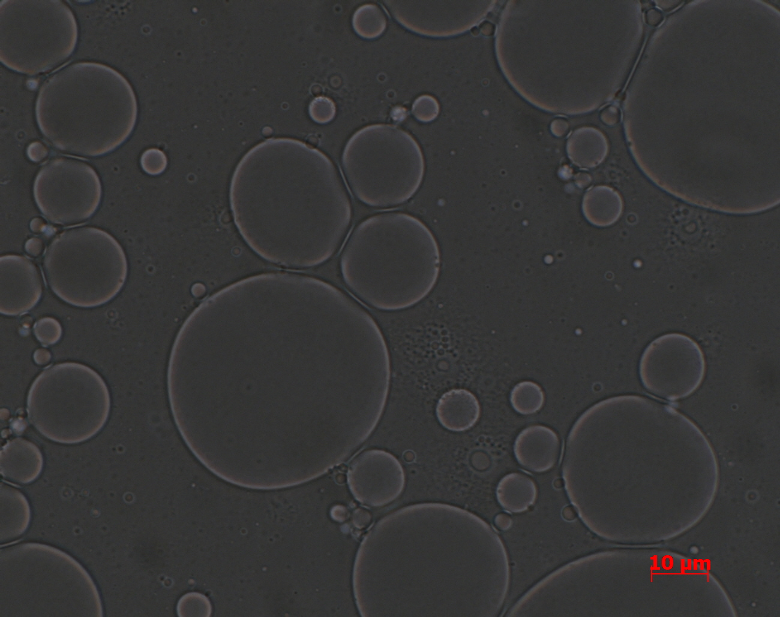
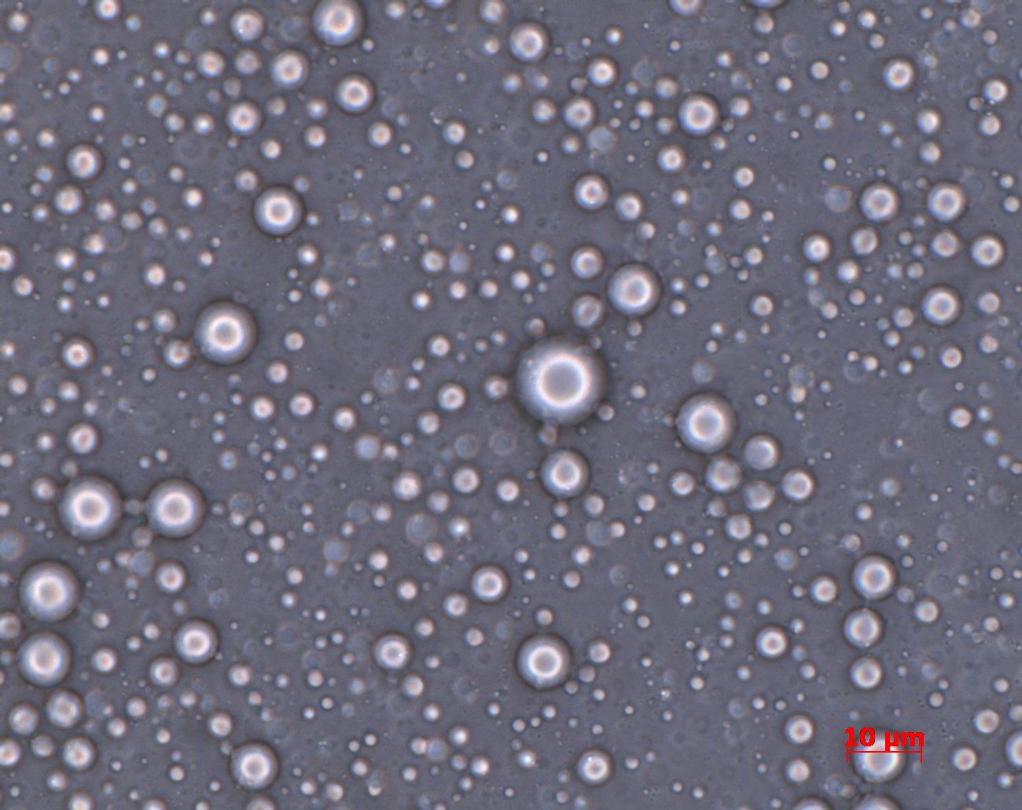
a)
b)
a)
b)

Supplementary Figure S2: Assess the quality of the emulsions at 100x magnification with a Laser Scanner LSM 510 microscope (a) Water-in-oil-emulsions after 1 min and (b) 3 min of vortexing. Scale bar represents 10 μm.

Bioanalyser analysis of cDNA amplification: open PCR versus ePCR (Figure 2a)

The cDNA was reverse transcribed from human total RNA applying the MINT cDNA synthesis Kit from Evrogen (Russia; purchased from BioCat, Germany). For further amplification, the manufacturers PCR master mix composition and PCR protocol was adapted to use in emulsions. After 15 amplification cycles, PCR product was purified (final volume 36 µl) and all of it was used as template for remaining cycles in a second ePCR. BSA was obtained from NEB, USA. Human blood RNA was used for creating the cDNA according the Evrogen’s instruction manual.
ePCR master mix composition using MINT kit components.

Reagent | Final concentration
Encyclo PCR Buffer | 1x
dNTPs | 0,2 mM
PCR Primer M1 | 0,4 µM
Encyclo Polymerase Mix | 1x
BSA | 1 µg/µl
Template ss cDNA | 1 µl

ePCR cycle parameters for dsDNA preparation after cDNA synthesis

1.) 95°C for 1 min
2.) 95°C for 15 sec
3.) 66°C for 20 sec
4.) 72°C for 3 min
5.) go to step 2; repeat 14 times
6.) 66°C for 15 sec
7.) 72°C for 3 min

Oligo

Name |  | Sequence | obtained from
M1 | Primer | 5’-AAG CAG TGG TAT CAA CGC AGA GT-3’ | Evrogen

SELEX library amplification in open PCR and ePCR (Figure 2b)

The amplified synthetic DNA library and used primers were obtained from Purimex (Germany) and Eurofins (Germany). PCR was carried out under the hereinafter referred conditions. As template different amount of molecules were used.
DNA fragments and PCR mix were analysed on 3% agarose gel (UltraPureTM Agarose, Invitrogen, Germany) using 20 bp ladder (O´RangeRulerTM, Fermentas, Germany).

Library PCR master mix

Reagent | Final concentration
10x bufferB (Roboklon) | 1x
dNTPs | 0,2 mM
T7Pro5 | 2 µM
PO4F6Pro3 | 2 µM
Taq | 0,025 U/µl
BSA | 1 µg/µl
Template DNA | 500 ng (20 pmol)

Library PCR cycle parameters

1.) 95°C for 30 s
2.) 95°C for 2 min
3.) 56°C for 1 min
4.) 72°C for 1 min
5.) go to step 2; repeat 1 time
6.) 95°C for 2 min
7.) 60°C for 1 min
8.) 72°C for 1min
9.) go to step 6; repeat 7 times
10.) 72°C for 5 min
11.) 4°C hold

Oligonucleotides

Name |  | Sequence | obtained from
B40 | Library | 5’-TGA CAC CGT ACC TGC TCT N40 AAG CAC GCC AGG GAC TAT | Purimex
T7Pro5 | Primer | 5’-GTA ATA CGA CTC ACT ATA GGA CAC CGT ACC TGC TCT | Eurofins
PO4F6Pro3 | Primer | PO4-5’-GGA AAA AAA TAG TCC CTG GCG TGC TT | Purimex

